Blanton-Peale Pastoral Care & Counseling Program-English
Application for Admission

Required Documents
- Admission application form (See below)
- Autobiographical Statement
Type a concise autobiography including the reasons you are seeking admission to this program and how you plan to use your training. Also, what are your learning goals? What do you expect to get out of this program?
- Official transcript (bachelor’s degree or its equivalent), a graduation certificate, and one photo (passport size).
- 1 Recommendation letter from someone who knows you well, other than family.
- International students must submit the following additional documents:
- Copies of all previous I-20s, including those of family members
- Copies of passports, including those of family members
- Proof of current address such as electric bill or phone bill
- Proof of financial guarantee such as recent bank statements
  - Support from family: bank statement and support letter
  - Support from non-family: bank statement and support letter
  - Support letter: “I, (name), who is (relationship) of (the applicant’s name), intend to support the applicant with $(amount)/yr for the next (number of years) years for the education at Blanton-Peale Care & Counseling Program.”
- Amount of Financial guarantee: $12,000.00 (single), $17,000.00 (family of 2), $21,000.00 (family of 3) and $25,000.00 (family of 4)
- Submission of application package: Email scanned copies of all the application documents to CCP@blantonpeale.org.

Application Process and Fees
- Application Process
- Complete the application by emailing the scanned application package to CCP@blantonpeale.org
- Admission letter, after the review of application documents, is usually emailed within a week.
- International students must have an interview with the director, Dr. Angella Son.
- International students will be provided with a transfer form, which should be sent to their current institution and request their record transfer to Blanton-Peale Institute.
- After transferring your record, your I-20 will be processed, and the initial I-20 will be registered with Sevis.
- Registered I-20 will be issued and sent to you after the full payment of tuition and fees.
- Registration: Before the semester begins, information on the start of the semester and orientation for new students will be sent via email.
- Registration is complete when the tuition ($2,025), registration fee ($70), application fee ($100) and I20 fee ($100) are submitted before the school registration deadline.
- Tuition and Fees
All the online receipts for payments should be sent to ason@blantonpeale.org.
- Application fee: $100.00
- I-20 fee: $100.00
- Registration fee: $70.00
- Tuition: $2,025.00 (9 credits)
- Total amount for new students: $100.00+$100.00+$70.00+$2,025.00= $2,295.00 (9 cr)

Contact:
- Admission Office Email: CCP@blantonpeale.org;
- Director Dr. Angella Son: 201-919-1809 or ason@blantonpeale.org

Online Submission of Tuition
- Go to www.blantonpeale.org

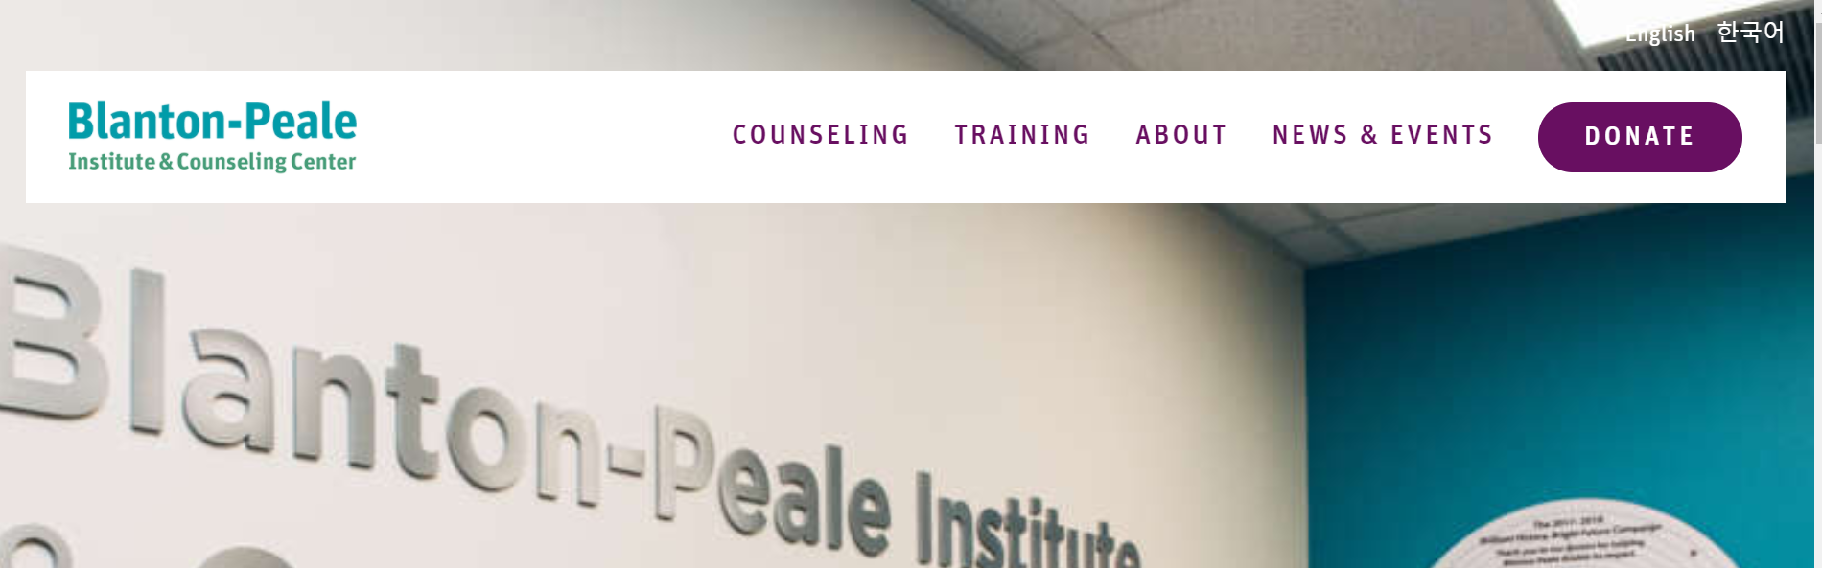
- Click “Training,” scroll down and click on “Make a Payment.”
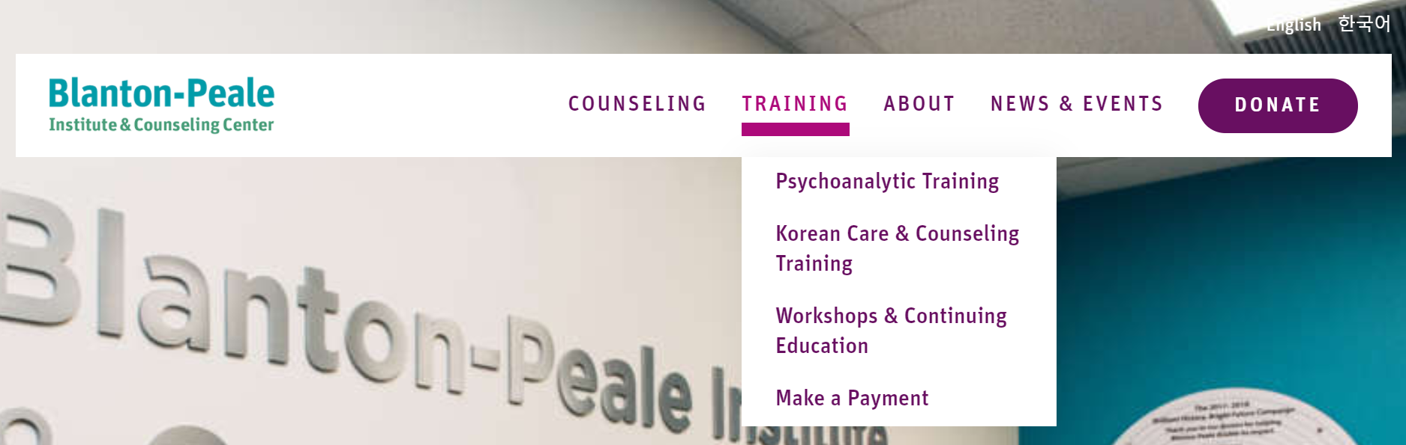
- Click “Pay Online.”
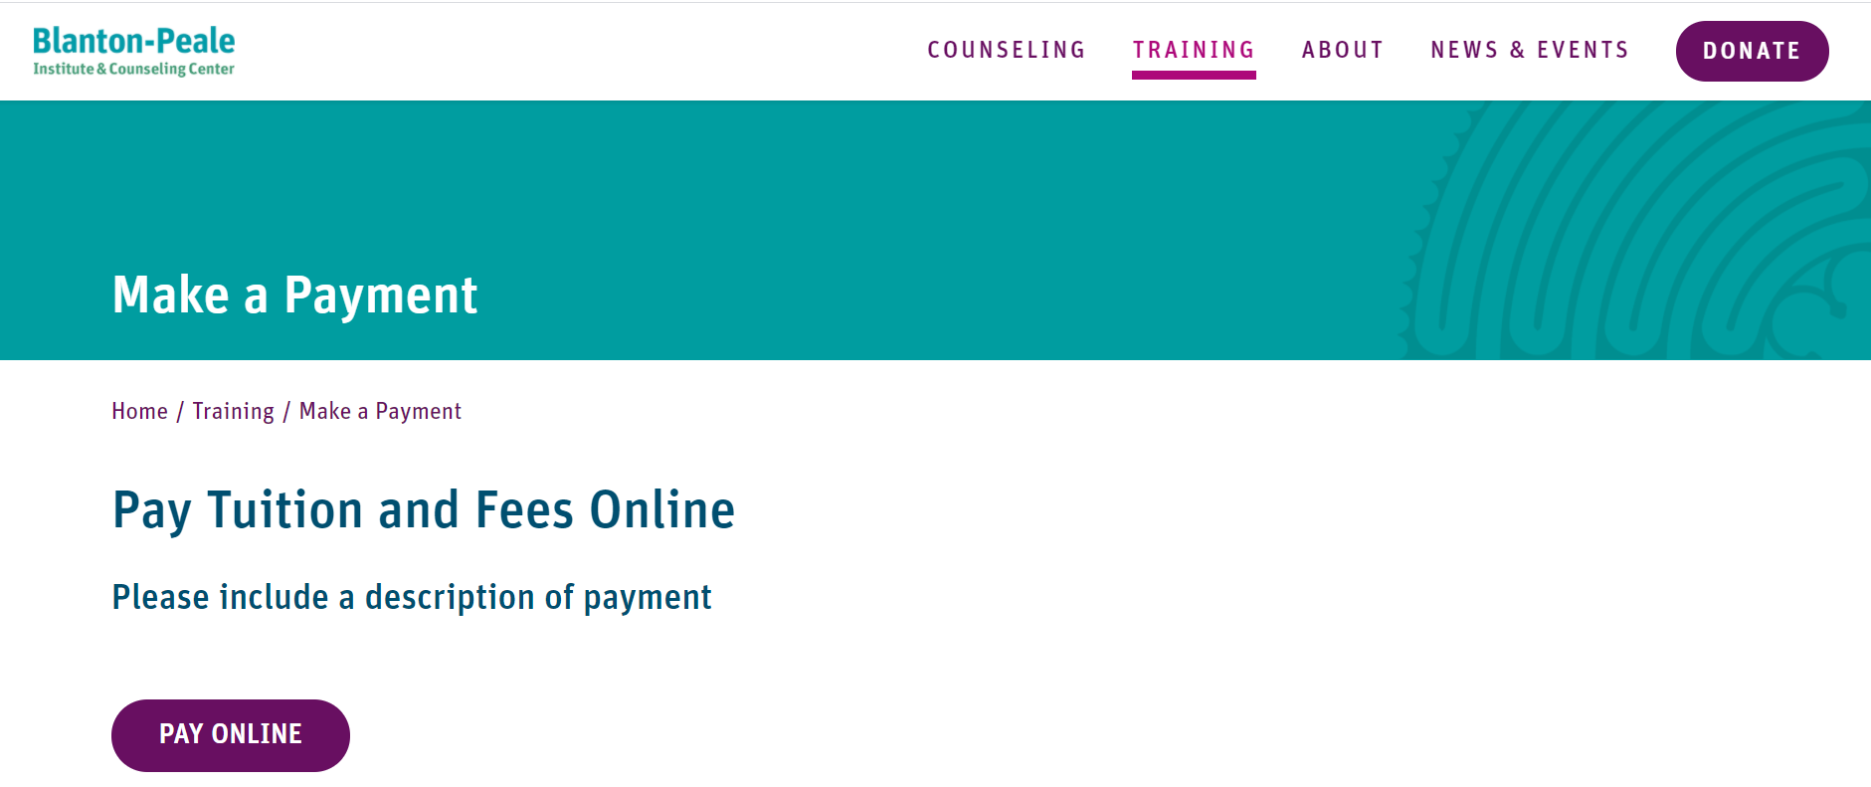
- Click “Pay for Training.”
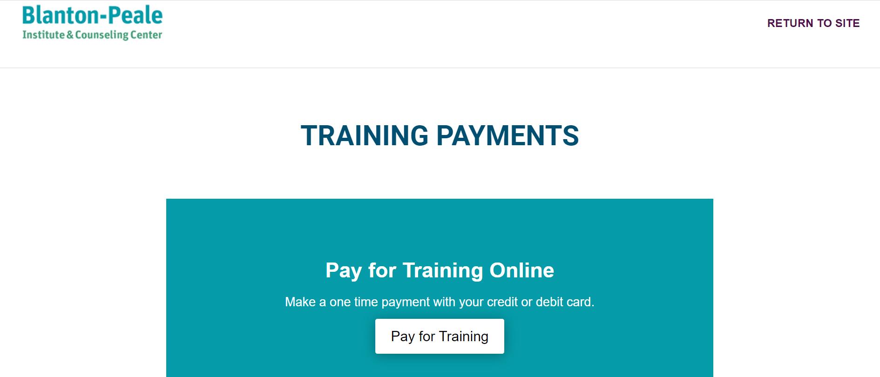
- Type in your name and “BPCCP-English” and your year of study for “Course Description/Purpose of Payment.”
Payment Amount: Current students: $2,095.00 ($2,025 + $70 registration fee)
New students $2,295 ($2,095 + $100 I20 fee + $100 application fee)
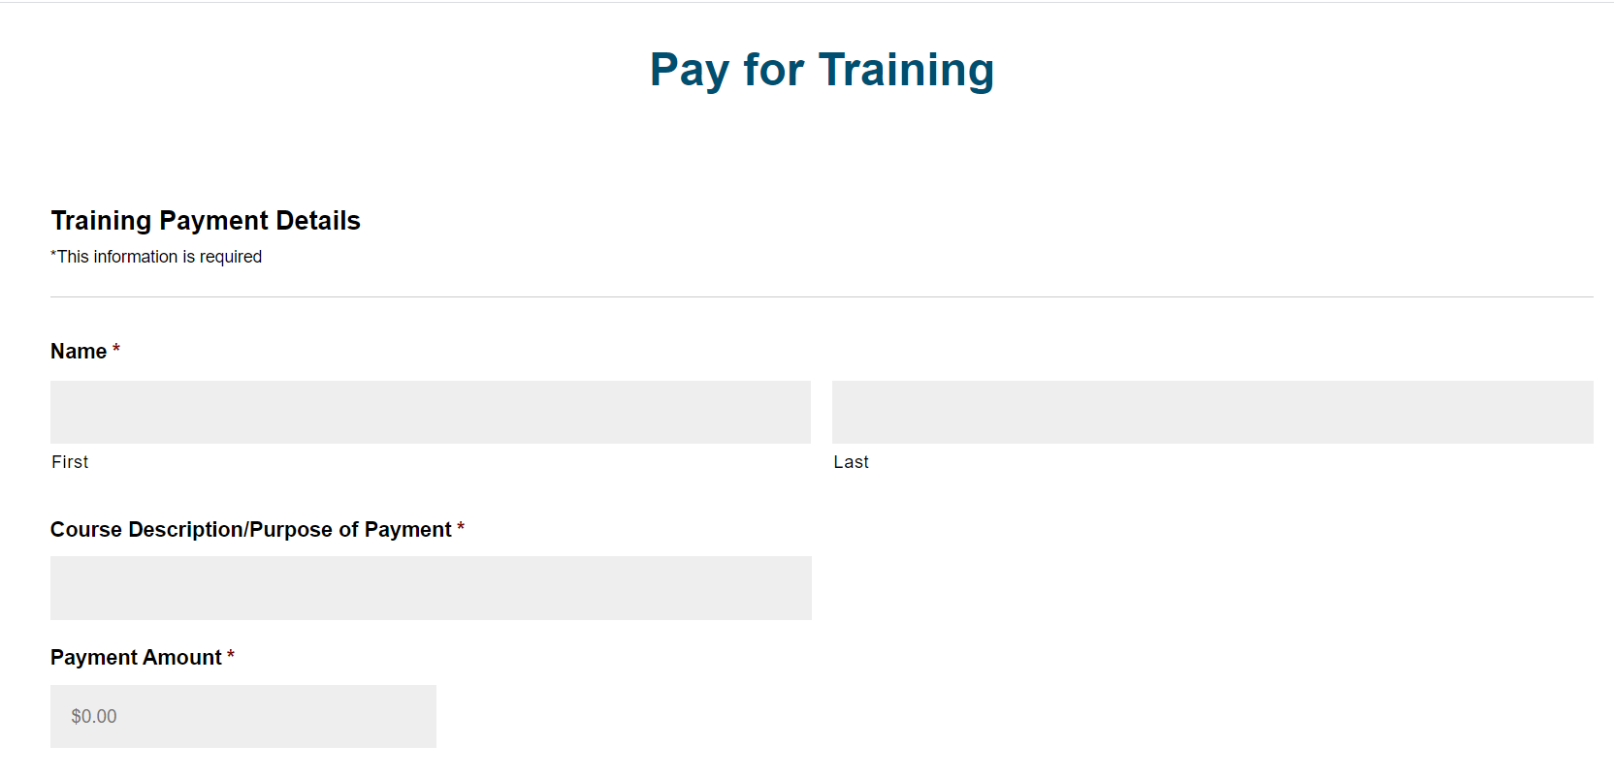
- Type in payment information and click “Submit Payment.”
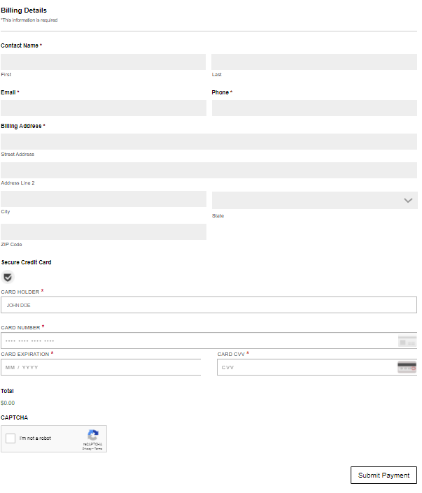
- Email your payment receipt to ason@blantonpeale.org

APPLICATION FORM

Application Date: Date Received:
1. Personal Information
Name ____________________________
Home Address (Street)_________________________________________________________
(City)_______________________________ (State) ______ (ZIP code) _________________
Address in home country (International Students)
________________________________________________________________________________
Phone (Current ) Home _____________________ _______ Cell _____________________________
E-mail ____________________________________________________________________
Date Of Birth ________________________________ Gender : ____________________
Current Status:
U.S. Citizen ◻ Permanent Resident ◻ SSN#___________________________
International Student(F-1) SEVIS ID # ___________________________________________________________
Non-US Citizen ◻ Home Country ID Number ____________________________________
Marital Status (International Students for F-2 Visa):
Single ◻ Married ◻ Divorced ◻ Other____________________
Name of Spouse _______________________________________________
Name, Gender and Ages of Children
_______________________________________________________________________
_______________________________________________________________________
_______________________________________________________________________
_______________________________________________________________________
_______________________________________________________________________
Emergency Contact
Name __________________________ Relationship _____________________ Phone_______________________________

2. Education Background:
Final Degree: __________________________ Major ____________________________
Name of School: _____________________________________________________
Address of School: _____________________________________________________________

3. Experiences of work, volunteering and training
________________________________________________________________________________________________________________________________________________________________________________________________________________________________________________________________________________________________________________________________________________________________________________________________________________________________________________________________________________________________________________________________________________________________________________________________________________________________________________________________________________________________________

4. Autobiographical Statement

I acknowledge with my signature that all the information provided here is accurate to the best of my knowledge.

Name: ___________________________________ Signature: _______________________
Date: _______________

After the application has been received, an admission letter will be emailed to you once your admission to the program is reviewed.

